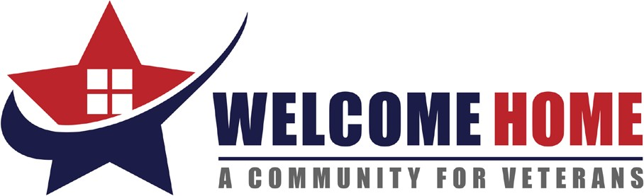

LIST OF NEEDS
Fall 2022 (September/October)

- New Women’s T-shirts (sizes S-XL)
- New Men’s Thermal Bottoms. (sizes L-XXL)
- New Coffee Maker
- New Bed Pillows
- Facial Tissues
- Pantry Staples: Non-perishable, canned, and dry goods (canned foods such as fruit, veggies, soups, sauces, beans, and dry goods, such as pasta, rice, boxed meals, sugar, flour, coffee, etc.)
- New Mainstays Rubber Bathmats (18x36)
- New or Gently Used dish sets (including plates and bowls)
- New Medium Women’s Underwear
- New White Men’s Undershirts (sizes Medium – XXL)
- New Coffee Makers
- 7-Gallon plastic trash cans
- New Full-Size Sheets
- New Twin-Size Sheets
- New Twin Comforters
- Men and Women’s Deodorant
- $10.00 and $15.00 Walmart Gift Cards and Breaktime Gas Cards (to be used for rewards for Veteran Program Participants going beyond the call of duty)

Because of our generous supporters, we have an overabundance of socks at this time and request that all sock donations be delivered to other local organizations in need.

