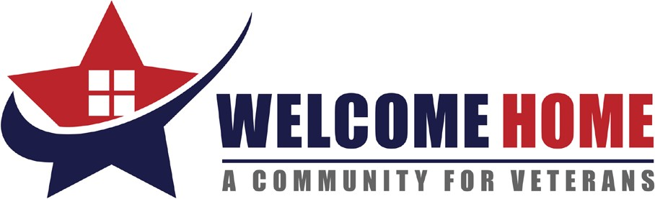

LIST OF NEEDS
Summer 2022

- New Women’s T-shirts (sizes S-XL)
- New Men’s Thermal Bottoms. (sizes L-XXL)
- New Coffee Maker
- New Bed Pillows
- Facial Tissues
- Pantry Staples: Non-perishable, canned, and dry goods (canned foods such as fruit, veggies, soups, sauces, beans, and dry goods, such as pasta, rice, boxed meals, sugar, flour, coffee, etc.)
- New Mainstays Rubber Bathmats (18x36)
- New or Gently Used serving utensils (Large Spoons, Ladles, Spatulas, and Potato Peelers) for Transitioning into Housing
- New Small, Medium, Large, and XL Sized Men’s Underwear (brief and boxer)
- New Medium Women’s Underwear
- New White Men’s Undershirts (sizes Medium – XXL)
- New Laundry Baskets
- 7-Gallon plastic trash cans
- New Full-Size Sheets
- New Twin-Size Sheets
- New Twin Comforters
- Flip flops – Men and Women – Assorted Sizes
- Men and Women’s Deodorant
- $10.00 and $15.00 Walmart Gift Cards and Breaktime Gas Cards (to be used for rewards for Veteran Program Participants going beyond the call of duty)

Because of our generous supporters, we have an overabundance of socks at this time and request that all sock donations be delivered to other local organizations in need.

