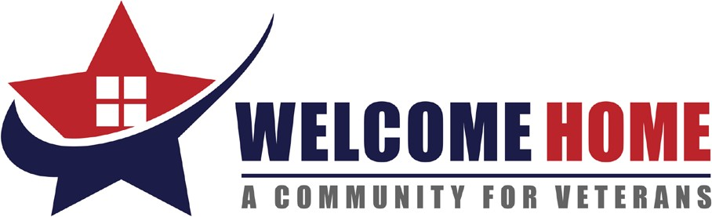

LIST OF NEEDS
Spring 2022

- New Women’s T-shirts (sizes S-XL)
- New Men’s Thermal Bottoms. (sizes L-XXL)
- Pantry Staples: Non-perishable, canned, and dry goods (canned foods such as fruit, veggies, soups, sauces, beans, and dry goods, such as pasta, rice, boxed meals, sugar, flour, coffee, etc.)
- Manual-can openers
- New Mainstays Rubber Bathmats (18x36)
- New or Gently Used serving utensils (Large Spoons, Ladles, Spatulas and Potato Peelers) for Transitioning into Housing
- New Small, Medium, Large, and XL Sized Men’s Underwear (brief and boxer)
- New Medium Women’s Underwear
- New White Men’s Undershirts (sizes Medium – XXL)
- New Laundry Baskets
- 7-Gallon plastic trash cans
- New Full-Size Sheets
- New Twin-Size Sheets
- Men and Women’s Deodorant
- $10.00 and $15.00 Walmart Gift Cards and Breaktime Gas Cards (to be used for rewards for Veteran Program Participants going beyond the call of duty)

Because of our generous supporters, we have an overabundance of socks at this time and request that all sock donations be delivered to other local organizations in need.

